Methodology
5th edition – 2022-2023

“Climate survey V”, conducted by BVA for the European Investment Bank.

Survey conducted online (computer, tablet or mobile) in August 2022, in all 27 EU countries, United-Kingdom, China and the US.
Respondents have been randomly selected among nationally representative panels. Panellists participate via self-administered web surveys.

Total sample of 26,000 people composed of 30 representative samples of the population aged 15 and over in each country (16+ for Luxembourg).

The representativity of samples was ensured through the quota method and samples in each country were weighted according to gender, age, occupation and region.

The size of the representative citizen panel in each country is as follows:
Country | Sample size | Language used
Germany | 1000 | German
France | 1000 | French
Spain | 1000 | Spanish
Italy | 1000 | Italian
Netherlands | 1000 | Dutch
Denmark | 1000 | Danish
Sweden | 1000 | Swedish
Finland | 1000 | Finnish
Belgium | 1000 | French, Flemish
Czech Republic | 1000 | Czech
Ireland | 1000 | English
Poland | 1000 | Polish
Portugal | 1000 | Portuguese
Austria | 1000 | German
Greece | 1000 | Greek
Hungary | 1000 | Hungarian
Bulgaria | 1000 | Bulgarian
Romania | 1000 | Romanian
Slovakia | 500 | Slovak
Estonia | 500 | Estonian
Latvia | 500 | Latvian
Lithuania | 500 | Lithuanian
Slovenia | 500 | Slovenian
Cyprus | 500 | Greek
Malta | 500 | English
Croatia | 1000 | Croatian
Luxembourg | 500 | French, German, Luxembourgish
UK | 1000 | English
USA | 1000 | English
China | 1000 | Simplified Chinese
Margin of error

This study presents results subject to the margins of error inherent in statistical laws. The table below shows the values of the margins of error (at the 95% level of confidence) according to the result obtained and the size of the sample considered.

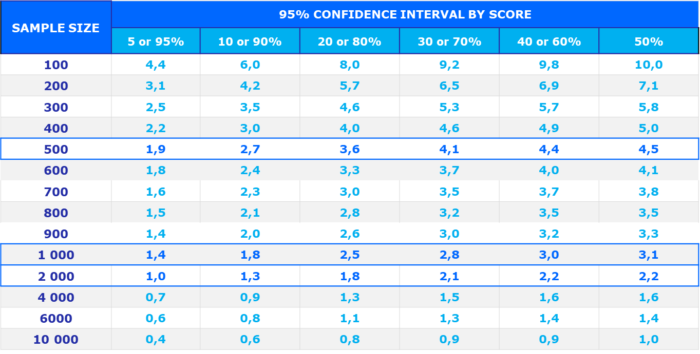

Example: For a sample of 2,000 respondents, for a survey percentage of 20%, the margin of error is 1,8. Therefore the percentage has 95% chance of being between 18,2% and 21,8%.

