Methodological note

EIB Climate study – 2023-2024

Focus countries of Latin America and the Caribbean

Context

The EIB has been carrying out an international survey on climate change since 2018, in the 27 countries of the European Union, the United States, China and the United Kingdom. This study aims to establish the positioning of the EIB as one of the major players in the fight against climate change.

Like all public development banks, the EIB participates in the Finance in Common summit. This summit aims to encourage cooperation and bring the financial community together around common action in favor of the climate and the Sustainable Development Goals (SDGs). This year, the Finance in Common Summit is being held in early September in Cartagena, Colombia. It is with this in mind that the EIB wanted to take an interest in the perception of climate change and its impact on populations, as well as expectations concerning public policies to respond to the climate emergency, in some American countries. Latin and Caribbean.

Methodology

The questionnaire was drafted jointly by the EIB and BVA, relying within the EIB on climate experts and heads of offices based in each of the countries questioned, who were thus able to share their experience and knowledge of the realities of country in which they have been established for several years.

Survey conducted online (computer, tablet or mobile) from May 5 to June 1, ²⁰²³ , in 13 countries in Latin America and the Caribbean.
Respondents were randomly selected from nationally representative panels. Panelists participate via self-administered web surveys.

Total sample of 10,587 people made up of 13 representative samples of the population aged 15 and over in each country.

The representativeness of the samples was ensured by the quota method and the samples from each country were weighted according to sex, age and region.

The size of the representative panel of citizens in each country is as follows:

Country | Sample size | Language used
Argentina | 1001 | Spanish
Brazil | 1012 | Portuguese
Chile | 1000 | Spanish
Colombia | 1000 | Spanish
Costa Rica | 1011 | Spanish
Dominican Republic | 510 | Spanish
Ecuador | 1000 | Spanish
salvador | 510 | Spanish
Mexico | 1015 | Spanish
Panama | 511 | Spanish
Paraguay | 510 | Spanish
Peru | 1001 | Spanish
Uruguay | 506 | Spanish

Margin of error

This study is subject to the margins of error inherent in statistical laws. The table below indicates the values of the margins of error (at the 95% confidence level) depending on the result obtained and the size of the sample considered.

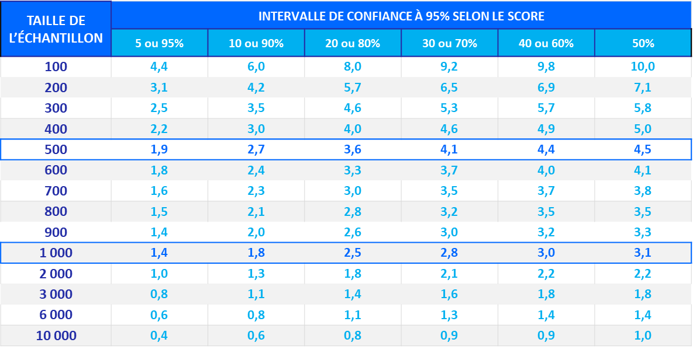

Example: Based on a sample of 1000 respondents, for a percentage of 20%, the margin of error is 2.5. The percentage thus has a 95% chance of being between 17.5% and 22.5%.

